SEC Form 3
FORM 3 | UNITED STATES SECURITIES AND EXCHANGE
 | COMMISSION
 |  |  | OMB APPROVAL
 | Washington, D.C. 20549
 |  |  | OMB Number: | 3235-
 | INITIAL STATEMENT OF BENEFICIAL OWNERSHIP OF |  |  | 0104
 |  |  | Estimated average burden
 | SECURITIES |  |  | 0.5
hours per
response:

Filed pursuant to Section 16(a) of the Securities Exchange Act of 1934
or Section 30(h) of the Investment Company Act of 1940
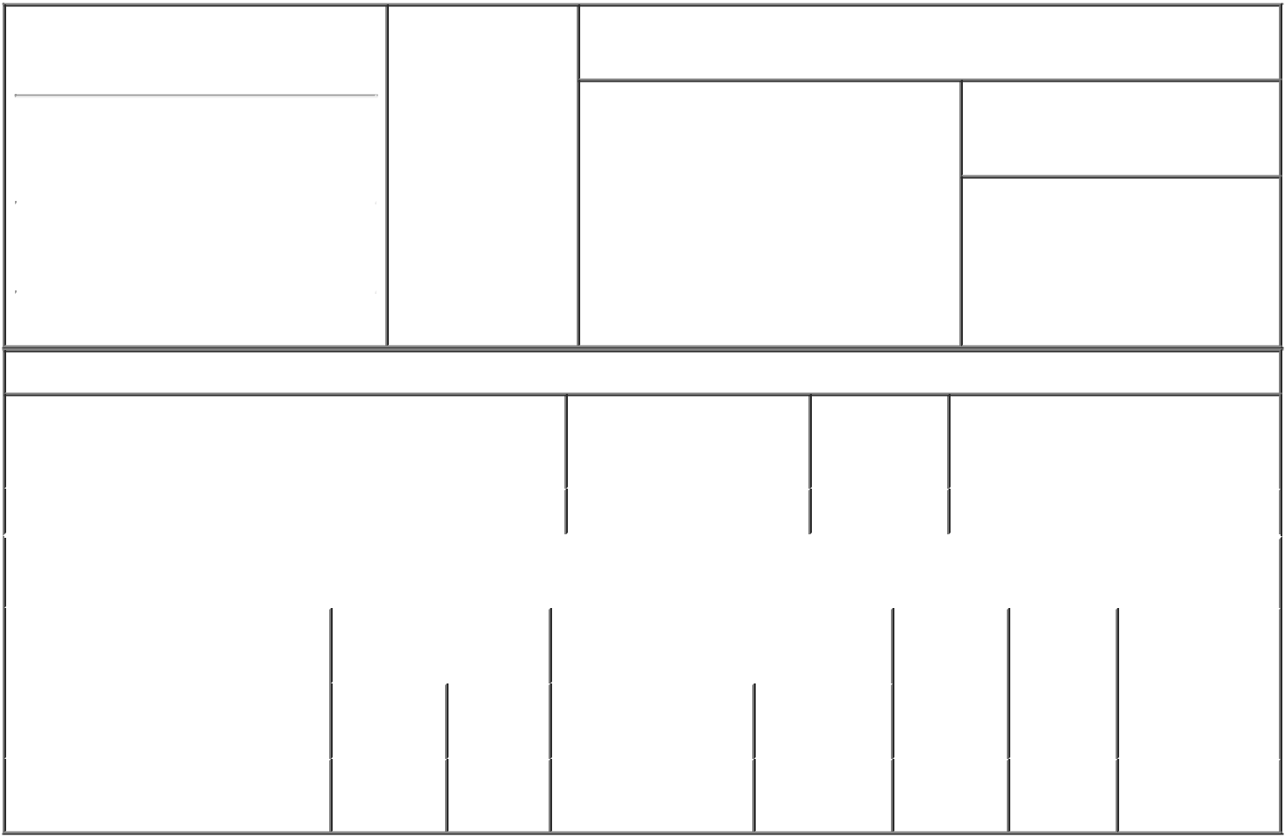

1. Name and Address of Reporting Person |  |  | * | 2. Date of Event
 |  |  |  | Requiring Statement
 | InCube Labs, L.L.C.
 |  |  |  | (Month/Day/Year)
 |  |  |  | 07/29/2021

3. Issuer Name and Ticker or Trading Symbol

Rani Therapeutics Holdings, Inc. [ RANI ]

(Last) | (First) | (Middle)
2051 RINGWOOD AVE.
(Street)
SAN JOSE | CA | 95131
(City) | (State) | (Zip)

- Relationship of Reporting Person(s) to Issuer
(Check all applicable)

Director X 10% Owner

Officer (give Other (specify
title below) below)

- If Amendment, Date of Original Filed (Month/Day/Year)

07/29/2021

- Individual or Joint/Group Filing (Check Applicable Line)

- Form filed by One Reporting Person

Form filed by More than One Reporting Person

Table I - Non-Derivative Securities Beneficially Owned

1. Title of Security (Instr. 4) | 2. Amount of Securities | 3. Ownership | 4. Nature of Indirect Beneficial
 | Beneficially Owned (Instr. | Form: Direct | Ownership (Instr. 5)
 | 4) | (D) or Indirect
 |  | (I) (Instr. 5)

 | Class B Common Stock |  |  |  | 22,389,982⁽¹⁾ | D
 |  |  | Table II - Derivative Securities Beneficially Owned
 |  | (e.g., puts, calls, warrants, options, convertible securities)
 | 1. Title of Derivative Security (Instr. |  | 2. Date Exercisable and |  | 3. Title and Amount of Securities |  | 4. | 5. | 6. Nature of
4) |  |  | Expiration Date |  | Underlying Derivative Security (Instr. |  | Conversion | Ownership | Indirect
 |  |  | (Month/Day/Year) |  | 4) |  | or Exercise | Form: | Beneficial
 |  |  |  |  |  |  | Price of | Direct (D) | Ownership (Instr.
 |  |  |  |  |  | Amount or
 |  |  |  |  |  |  | Derivative | or Indirect | 5)
 |  |  | Date | Expiration | Title | Number of | Security | (I) (Instr. 5)
 |  |  | Exercisable | Date |  | Shares
 | Class A Common LLC Units⁽²⁾⁽³⁾ | (2) |  | (2) | Class A Common | 22,389,982⁽¹⁾ | (2)(3) | D
 |  |  |  |  | Stock⁽²⁾

Explanation of Responses:

- This amendment is being filed to correctly reflect the shares held.

- Represents Common LLC Units of Rani Therapeutics, LLC, a direct subsidiary of the Issuer. The Common LLC Units are redeemable at the election of the Reporting Person at any time for newly-issued Class A Common Stock of the Issuer ("Class A Shares") on a one-for-one basis or, if mutually agreed with the Issuer, a cash payment equal to the volume weighted average market price of one Class A Share for each Common LLC Unit redeemed (subject to customary adjustments, including for stock splits, stock dividends and reclassifications). However, the Issuer may elect to effect a direct exchange of such Class A Shares (or such cash, if mutually agreed) for such Common LLC Units.

- Upon the redemption or exchange by the Reporting Person of any Class A Common LLC Units, a number of Class B Common Stock of the Issuer ("Class B Shares") held by the Reporting Person equal to the number of Common LLC Units that are redeemed or exchanged will be automatically cancelled by the Issuer for no consideration.

Remarks:

/s/ Josh Seidenfeld,
Attorney-in-Fact for Mir _{08/02/2021}
Imran, President of InCube
Labs, LLC

** Signature of Reporting | Date
Person
Reminder: Report on a separate line for each class of securities beneficially owned directly or indirectly.
* If the form is filed by more than one reporting person, see Instruction 5 (b)(v).

- Intentional misstatements or omissions of facts constitute Federal Criminal Violations See 18 U.S.C. 1001 and 15 U.S.C. 78ff(a). Note: File three copies of this Form, one of which must be manually signed. If space is insufficient, see Instruction 6 for procedure.
Persons who respond to the collection of information contained in this form are not required to respond unless the form displays a currently valid OMB Number.

