SEC Form 3
FORM 3 | UNITED STATES SECURITIES AND EXCHANGE
 | COMMISSION
 |  |  | OMB APPROVAL
 | Washington, D.C. 20549
 |  |  | OMB Number: | 3235-
 | INITIAL STATEMENT OF BENEFICIAL OWNERSHIP OF |  |  | 0104
 |  |  | Estimated average burden
 | SECURITIES |  |  | 0.5
hours per
response:

Filed pursuant to Section 16(a) of the Securities Exchange Act of 1934
or Section 30(h) of the Investment Company Act of 1940
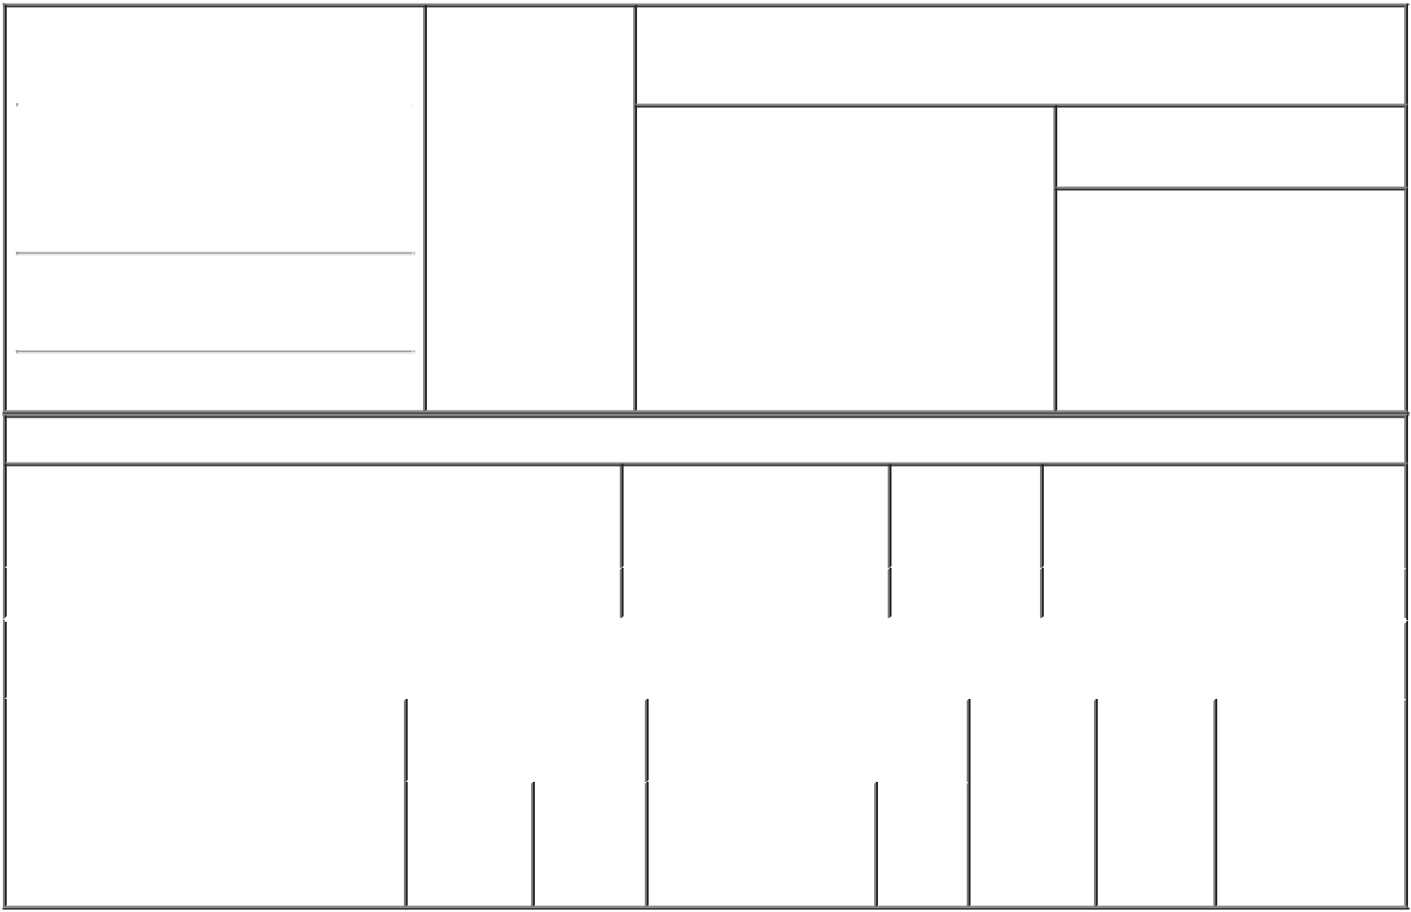

1. Name and Address of Reporting Person |  |  | * | 2. Date of Event
 |  |  |  | Requiring Statement
 | Baranowski Lyn
 |  |  |  | (Month/Day/Year)
 |  |  |  | 11/10/2021

3. Issuer Name and Ticker or Trading Symbol

Rani Therapeutics Holdings, Inc. [ RANI ]

(Last) (First) (Middle)

C/O RANI THERAPEUTICS LLC 2051 RINGWOOD AVE.

(Street)
SAN JOSE CA | 95131

- Relationship of Reporting Person(s) to Issuer
(Check all applicable)
X Director 10% Owner

Officer (give Other (specify
title below) below)

- If Amendment, Date of Original Filed (Month/Day/Year)

- Individual or Joint/Group Filing (Check Applicable Line)

- Form filed by One Reporting Person

Form filed by More than One Reporting Person

(City) (State) (Zip)

Table I - Non-Derivative Securities Beneficially Owned

1. Title of Security (Instr. 4) | 2. Amount of Securities | 3. Ownership | 4. Nature of Indirect Beneficial
 | Beneficially Owned (Instr. | Form: Direct | Ownership (Instr. 5)
 | 4) | (D) or Indirect
 |  | (I) (Instr. 5)

 | Class A Common Stock |  |  |  | 6,087⁽¹⁾ | D
 |  |  | Table II - Derivative Securities Beneficially Owned
 |  | (e.g., puts, calls, warrants, options, convertible securities)
 | 1. Title of Derivative Security (Instr. 4) |  | 2. Date Exercisable and |  | 3. Title and Amount of Securities |  |  | 4. | 5. | 6. Nature of
 |  |  | Expiration Date |  | Underlying Derivative Security |  |  | Conversion | Ownership | Indirect Beneficial
 |  |  | (Month/Day/Year) |  | (Instr. 4) |  |  | or Exercise | Form: | Ownership (Instr.
 |  |  |  |  |  |  |  | Price of | Direct (D) | 5)
 |  |  |  |  |  | Amount
 |  |  |  |  |  |  |  | Derivative | or Indirect
 |  |  |  |  |  | or |  | Security | (I) (Instr. 5)
 |  |  |  |  |  | Number
 |  |  | Date | Expiration |  | of
 |  |  | Exercisable | Date | Title | Shares

Explanation of Responses:

1. The shares subject to the restricted stock award vest as follows: 1/48th of the shares subject to the award vest monthly over four years from February 4, 2021.

Remarks:

Exhibit 24 - Power of Attorney

 | /s/ Josh Seidenfeld,
 | Attorney-in-Fact for Lyn 11/12/2021
 | Baranowski
 | ** Signature of Reporting |  |  |  | Date
 | Person
Reminder: Report on a separate line for each class of securities beneficially owned directly or indirectly.
* If the form is filed by more than one reporting person, see Instruction 5 (b)(v).

- Intentional misstatements or omissions of facts constitute Federal Criminal Violations See 18 U.S.C. 1001 and 15 U.S.C. 78ff(a). Note: File three copies of this Form, one of which must be manually signed. If space is insufficient, see Instruction 6 for procedure.
Persons who respond to the collection of information contained in this form are not required to respond unless the form displays a currently valid OMB Number.

LIMITED POWER OF ATTORNEY FOR
SECTION 16 REPORTING OBLIGATIONS

Know all by these presents, that the undersigned hereby constitutes and appoints Talat Imran and Svai Sanford of Rani Therapeutics Holdings, Inc. and Josh Seidenfeld and Nguyen X. Nguyen of Cooley LLP, or any of them signing singly, with full power of substitution, the undersigned's true and lawful attorney in fact to:

- execute for and on behalf of the undersigned, in the undersigned's capacity as an officer, director or beneficial owner of more than 10% of a registered class of securities of Rani Therapeutics Holdings, Inc. (the "Company"), Forms

3, 4 and 5 (including any amendments thereto) in accordance with Section 16(a) of the Securities Exchange Act of 1934, as amended (the "Exchange Act") and the rules thereunder and a Form ID, Uniform Application for Access Codes to File on
EDGAR;

- do and perform any and all acts for and on behalf of the undersigned that may be necessary or desirable to execute such Forms 3, 4 or 5 or Form ID (including any amendments thereto) and timely file such forms with the United States Securities and Exchange Commission and any stock exchange or similar authority; and

- take any other action of any nature whatsoever in connection with the foregoing which, in the opinion of such attorney-in-fact, may be of benefit, in the best interest of, or legally required by, the undersigned, it being understood that the documents executed by such attorney-in-fact on behalf of the undersigned pursuant to this Power of Attorney shall be in such form and shall contain such terms and conditions as such attorney-in-fact may approve in such attorney-in-fact's discretion.

The undersigned hereby grants to each such attorney-in-fact full power and authority to do and perform any and every act and thing whatsoever requisite, necessary or proper to be done in the exercise of any of the rights and powers herein granted, as fully to all intents and purposes as the undersigned might or could do if personally present, with full power of substitution or revocation, hereby ratifying and confirming all that such attorney-in-fact, or such attorney-in-fact's substitute or substitutes, shall lawfully do or cause to be done by virtue of this power of attorney and the rights and powers herein granted. The undersigned acknowledges that the foregoing attorneys-in-fact, in serving in such capacity at the request of the undersigned, are not assuming, nor is the Company assuming, any of the undersigned's responsibilities to comply with Section 16 of the Exchange Act.

This Power of Attorney shall remain in full force and effect until the earliest to occur of (a) the undersigned is no longer required to file Forms 3, 4 and 5 with respect to the undersigned's holdings of and transactions in securities issued by the Company, (b) revocation by the undersigned in a signed writing delivered to the foregoing attorneys-in-fact or (c) as to any attorney-in-fact individually, until such attorney-in-fact is no longer employed by the Company or Cooley LLP.

IN WITNESS WHEREOF, the undersigned has caused this Power of Attorney to be executed as of this 9th day of November 2021.

/s/ Lyn Baranowski
____________________________________
Lyn Baranowski

