|  |  |  |  |  |  |  |  |  |  |  |  |  |  |  |  |  |  |  |  |  |  |  |  |  |  |  |  |  |  |  |  |  |  |  |  |  |  |  |  |  |
| --- | --- | --- | --- | --- | --- | --- | --- | --- | --- | --- | --- | --- | --- | --- | --- | --- | --- | --- | --- | --- | --- | --- | --- | --- | --- | --- | --- | --- | --- | --- | --- | --- | --- | --- | --- | --- | --- | --- | --- | --- |
| SEC Form 4 | | | | |  |  |  |  |  |  |  |  |  |  |  |  |  |  |  |  |  |  |  |  |  |  |  |  |  |  |  |  |  |  |  |  |  |  |  |  |
|  |  |  |  | **FORM 4** | | | | **UNITED STATES SECURITIES AND EXCHANGE COMMISSION** | | | | | | | | | | | | | | | | | | | | | |  |  |  |  |  |  |  |  |  |  |  |
|  |  |  |  |  |  |  |  |  |  |  |  |  |  |  |  |  | Washington, D.C. 20549 | | | |  |  |  |  |  |  |  |  |  |  |  |  |  |  |  |  |  |  |  |  |
|  |  |  |  |  |  |  |  |  |  |  |  |  |  |  |  |  |  |  |  |  |  |  |  |  |  |  |  | OMB APPROVAL | | | | | | | |  |
|  |  |  |  |  |  |  |  |  |  |  |  |  |  |  |  |  |  |  |  |  |  |  |  |  |  |  |  |  |  |  |  |  |
|  |  |  |  |  |  |  |  | **STATEMENT OF CHANGES IN BENEFICIAL OWNERSHIP** | | | | | | | | | | | | | | | | | | | | | |  |  |  | | |  |  |  |  |  |  |
|  |  |  | Check this box if no longer subject to | | | | |  |  | OMB Number: | | | 3235-0287 |  |  |  |  |  |
|  |  |  |  |  | Estimated average burden | | | | | | | |  |
|  |  |  | Section 16. Form 4 or Form 5 | | | | |  |  |  |  |  |  |  |  |  |  |  |  |  |  |  |  |  |  |  |  |  |  |  |  |  |
|  |  |  | obligations may continue. *See* | | | | |  | Filed pursuant to Section 16(a) of the Securities Exchange Act of 1934 | | | | | | | | | | | | | | | |  |  |  |  |  |  |  | hours per response: | | | 0.5 |  |  |  |  |  |
|  |  |  | Instruction 1(b). | |  |  |  |  |  |  |  |  |  |  |  |  |  |  |  |  |  |  |  |  |
|  |  |  |  |  |  |  |  |  |  |  |  |  |  |  |  |  |  |  |  |
|  |  |  |  |  |  |  |  |  |  |  |  |  |  | or Section 30(h) of the Investment Company Act of 1940 | | | | | | | | | |  |  |  |  |  |  |  |  |  |  |  |  |  |  |  |  |  |
|  |  |  |  | | | |  |  |  |  |  |  |  |  |  | | | |  | | |  |  |  |  |  |  | |  | | | | | | | | |  |  |  |
|  | 1. Name and Address of Reporting Person* | | | | | | |  |  |  |  |  | 2. Issuer Name **and** Ticker or Trading Symbol | | | | | | | | | |  |  |  | 5. Relationship of Reporting Person(s) to Issuer | | | | | | | | | | | | | |  |
|  |  |  | [Ausiello Dennis A](http://www.sec.gov/cgi-bin/browse-edgar?action=getcompany&CIK=0001381994) | | | | |  |  |  |  |  | [Rani Therapeutics Holdings, Inc.](http://www.sec.gov/cgi-bin/browse-edgar?action=getcompany&CIK=0001856725) [ RANI ] | | | | | | | | | | |  |  | (Check all applicable) | | | | | | |  |  |  |  |  |  |  |  |
|  |  |  |  |  |  |  |  |  |  |  |  |  |  |  |  |  |  |  |  |  | X | |  | Director |  |  |  |  | 10% Owner | | | | | |  |
|  |  |  |  |  |  |  |  |  |  |  |  |  |  |  |  |  |  |  |  |  |  |  |  |  |  |  |  |  |  |  |  |
|  |  |  |  |  |  |  |  |  |  |  |  |  | 3. Date of Earliest Transaction (Month/Day/Year) | | | | | | | | | |  |  |  |  |  |  | Officer (give title | | | |  | Other (specify | | | | | |  |
|  |  |  |  |  |  |  |  |  |  |  |  |  |  |  |  |  |  |
|  |  |  | (Last) |  | (First) | | | (Middle) | 05/25/2023 | | | | | | | |  |  |  |  |  |  |  |  |  |  |  |  | below) |  |  |  |  | below) |  |  |  |  |  |  |
|  |  |  | C/O RANI THERAPEUTICS LLC | | | | |  |  |  |  |  |  |  |  |  |  |  |  |  |  |  |  |  |  |  |  |  |  |  |  |  |  |  |  |  |  |  |  |  |
|  |  |  |  |  |  |  | 4. If Amendment, Date of Original Filed (Month/Day/Year) | | | | | | | | | | |  |  | 6. Individual or Joint/Group Filing (Check Applicable | | | | | | | | | | | | | |  |
|  |  |  |  |  |  |  |  |  |  |  |  |  |  |  |  |
|  |  |  | 2051 RINGWOOD AVE. | | | | |  |  |  |  |  |  |  |  |  |  |  |  |  |  |  |  |  |  | Line) | |  |  |  |  |  |  |  |  |  |  |  |  |  |
|  |  |  |  |  |  |  |  |  |  |  |  |  |  |  |  |  |  |  |  |  |  |  |  |  |  | X Form filed by One Reporting Person | | | | | | | | | | | | | |  |
|  | (Street) | | |  |  |  |  |  |  |  |  |  |  |  |  |  |  |  |  |  |  |  |  |  |  |  |  |  | Form filed by More than One Reporting | | | | | | | | | | |  |
|  |  |  |  |  |  |  |  |  |  |  |  |  |  |  |  |  |  |  |  |  |  |  |  |  |  | Person |  |  |  |  |  |  |  |  |  |  |  |
|  |  |  | SAN JOSE | | CA | | | 95131 |  |  |  |  |  |  |  |  |  |  |  |  |  |  |  |  |  |  |  |  |  |  |  |  |  |  |  |  |  |  |  |
|  |  |  |  |  |  |  |  |  |  |  |  |  |  |  |  |  |  |  |  |  |  |  |  |  |  |  |  |  |  |  |  |  |  |  |
|  |  |  |  |  |  |  |  |  |  |  |  |  | Rule 10b5-1(c) Transaction Indication | | | | | | | | | | |  |  |  |  |  |  |  |  |  |  |  |  |  |  |  |  |  |
|  |  |  | (City) |  | (State) | | | (Zip) |  |  |  |  |  |  |  |  |  |  |  |  |  |  |  |  |  |  |  |
|  |  |  |  |  |  |  |  |  |  | Check this box to indicate that a transaction was made pursuant to a contract, instruction or written plan that is intended to | | | | | | | | | | | | | | | | | | | | | | | | |  |
|  |  |  |  |  |  |  |  |  |  |  |  |  |  |  |  |
|  |  |  |  |  |  |  |  |  |  |  |  |  |  |  | satisfy the affirmative defense conditions of Rule 10b5-1(c). See Instruction 10. | | | | | | | | | | | | | | |  |  |  |  |  |  |  |  |  |  |  |
|  |  |  |  |  |  |  |  |  |  |  |  |  |  |  |  |  |  |  |  |  |  |  |  |  |  |  |  |  |  |  |  |  |  |  |  |  |  |  |  |  |
|  |  |  |  |  |  |  | **Table I - Non-Derivative Securities Acquired, Disposed of, or Beneficially Owned** | | | | | | | | | | | | | | | | | | | | | | |  |  |  |  |  |  |  |  |  |  |  |
|  |  | |  | | | |  |  | |  | | |  | | |  | |  |  |  |  |  | | | | |  |  |  | | | |  | |  | | |  |  |  |
|  | **1. Title of Security (Instr. 3)** | | | | | | | **2. Transaction** | | | | | | | | **2A. Deemed** | | **3.** | |  | **4. Securities Acquired (A) or** | | | | | | |  | **5. Amount of** | | | | **6. Ownership** | | **7. Nature** | | | | |  |
|  |  |  |  |  |  |  |  | **Date** |  |  |  |  |  |  |  | **Execution Date,** | |  | **Transaction** | | **Disposed Of (D) (Instr. 3, 4 and** | | | | | | |  | **Securities** |  |  |  | **Form: Direct** | | **of Indirect** | | | | |  |
|  |  |  |  |  |  |  |  | **(Month/Day/Year)** | | | | | | | | **if any** |  |  | **Code (Instr.** | | **5)** |  |  |  |  |  |  |  | **Beneficially** | | | | **(D) or Indirect** | | **Beneficial** | | | | |  |
|  |  |  |  |  |  |  |  |  |  |  |  |  |  |  |  | **(Month/Day/Year) 8)** | | | |  |  |  |  |  |  |  |  |  | **Owned Following** | | | | **(I) (Instr. 4)** | | **Ownership** | | | | |  |
|  |  |  |  |  |  |  |  |  |  |  |  |  |  |  |  |  |  |  |  |  |  |  |  |  |  |  |  |  | **Reported** |  |  |  |  |  | **(Instr. 4)** | | | | |  |
|  |  |  |  |  |  |  |  |  |  |  |  |  |  |  |  |  |  |  |  |  |  |  |  |  |  |  |  |  |  |  |  |  |  |  |
|  |  |  |  |  |  |  |  |  |  |  |  |  |  |  |  |  |  |  | **Code V** |  | **Amount** | | **(A) or** | | **Price** | | |  | **Transaction(s)** | | | |  |  |  |  |  |  |  |  |
|  |  |  |  |  |  |  |  |  |  |  |  |  |  |  |  |  |  |  |  | **(D)** |  |  | **(Instr. 3 and 4)** | | | |  |  |  |  |  |  |  |  |
|  |  |  |  |  |  |  |  |  |  |  |  |  |  |  |  |  |  |  |  |  |  |  |  |  |  |  |  |  |  |  |  |  |  |  |  |
|  |  |  |  |  |  |  |  | | |  | | |  | | | | | |  | | |  | | | | |  | |  |  |  |  |  |  |  |  |  |  |  |  |
|  |  |  |  |  |  |  | **Table II - Derivative Securities Acquired, Disposed of, or Beneficially Owned** | | | | | | | | | | | | | | | | | | | | | | |  |  |  |  |  |  |  |  |  |  |  |
|  |  |  |  |  |  |  |  | **(e.g., puts, calls, warrants, options, convertible securities)** | | | | | | | | | | | | | | | | | | | |  |  |  |  |  |  |  |  |  |  |  |  |  |
|  |  | |  |  |  |  |  |  |  |  | |  |  |  |  |  | |  | | | |  |  | | | |  |  | |  | | | |  |  | | | | |  |
|  | **1. Title of** | | | **2.** |  | **3. Transaction** | | **3A. Deemed** | **4.** | | |  |  |  |  | **5. Number of** | | **6. Date Exercisable and** | | | | | **7. Title and Amount** | | | | | **8. Price of** | | **9. Number of** | | | | **10.** | **11. Nature** | | | | |  |
|  | **Derivative** | | | **Conversion** | | **Date** | | **Execution Date,** |  | **Transaction** | | | | | | **Derivative** | | **Expiration Date** | | |  |  | **of Securities** | |  |  |  | **Derivative** | | **derivative** | | |  | **Ownership of Indirect** | | | | | |  |
|  | **Security** | | | **or Exercise** | | **(Month/Day/Year)** | | **if any** |  | **Code (Instr.** | | | | | | **Securities** | | **(Month/Day/Year)** | | |  |  | **Underlying** |  |  |  |  | **Security** | | **Securities** | | |  | **Form:** | **Beneficial** | | | | |  |
|  | **(Instr. 3)** | | | **Price of** |  |  |  | **(Month/Day/Year)** | **8)** | | |  |  |  |  | **Acquired (A)** | |  |  |  |  |  | **Derivative Security** | | | | | **(Instr. 5)** | | **Beneficially** | | | | **Direct (D)** | **Ownership** | | | | |  |
|  |  |  |  | **Derivative** |  |  |  |  |  |  |  |  |  |  |  | **or Disposed** | |  |  |  |  |  | **(Instr. 3 and 4)** | |  |  |  |  |  | **Owned** | | |  | **or Indirect** | **(Instr. 4)** | | | | |  |
|  |  |  |  | **Security** |  |  |  |  |  |  |  |  |  |  |  | **of (D) (Instr.** | |  |  |  |  |  |  |  |  |  |  |  |  | **Following** | | |  | **(I) (Instr. 4)** |  |  |  |  |  |  |
|  |  |  |  |  |  |  |  |  |  |  |  |  |  |  |  | **3, 4 and 5)** | |  |  |  |  |  |  |  |  |  |  |  |  | **Reported** | | |  |  |  |  |  |  |  |  |
|  |  |  |  |  |  |  |  |  |  |  |  |  |  |  |  |  |  |  |  |  |  |  |  |  |  |  |  |  |  | **Transaction(s)** | | | |  |  |  |  |  |  |  |
|  |  |  |  |  |  |  |  |  |  |  |  |  |  |  |  |  |  |  |  |  |  |  |  |  |  |  |  |  |  |  |  |  |  |  |  |  |
|  |  |  |  |  |  |  |  |  |  |  |  |  |  |  |  |  |  |  |  |  |  |  |  | **Amount** | | | |  |  | **(Instr. 4)** | | |  |  |  |  |  |  |  |  |
|  |  |  |  |  |  |  |  |  |  |  |  |  |  |  |  |  |  |  |  |  |  |  |  | **or** |  |  |  |  |  |  |  |  |  |  |  |  |  |  |  |  |
|  |  |  |  |  |  |  |  |  |  |  |  |  |  |  |  |  |  | **Date** | | **Expiration** | | |  | **Number** | | | |  |  |  |  |  |  |  |  |  |  |  |  |  |
|  |  |  |  |  |  |  |  |  |  | **Code V** | | | | | | **(A)** | **(D)** | **Exercisable** | | **Date** | | | **Title** | **of Shares** | | | |  |  |  |  |  |  |  |  |  |  |  |  |  |
|  |  | |  |  |  |  |  |  |  |  |  |  |  |  |  |  |  |  |  |  |  |  |  |  |  |  |  |  |  |  |  |  |  |  |  |  |  |  |  |  |
|  | Stock | | |  |  |  |  |  |  |  |  |  |  |  |  |  |  |  |  |  |  |  | Class A |  |  |  |  |  |  |  |  |  |  |  |  |  |  |  |  |  |
|  | Option | | |  |  |  |  |  |  |  |  |  |  |  |  |  |  |  |  |  |  |  | 101,276 | | |  |  |  |  |  |  |  |  |  |  |  |  |  |  |
|  | $4.11 |  | 05/25/2023 | |  |  |  | A | | | | | 101,276 |  | (1) | | 05/24/2033 | | | Common |  | $0.00 | | 101,276 | | | | D |  |  |  |  |  |  |
|  | (Right to | | |  |  |  |  |  |  |  |  |  |  |  |  |

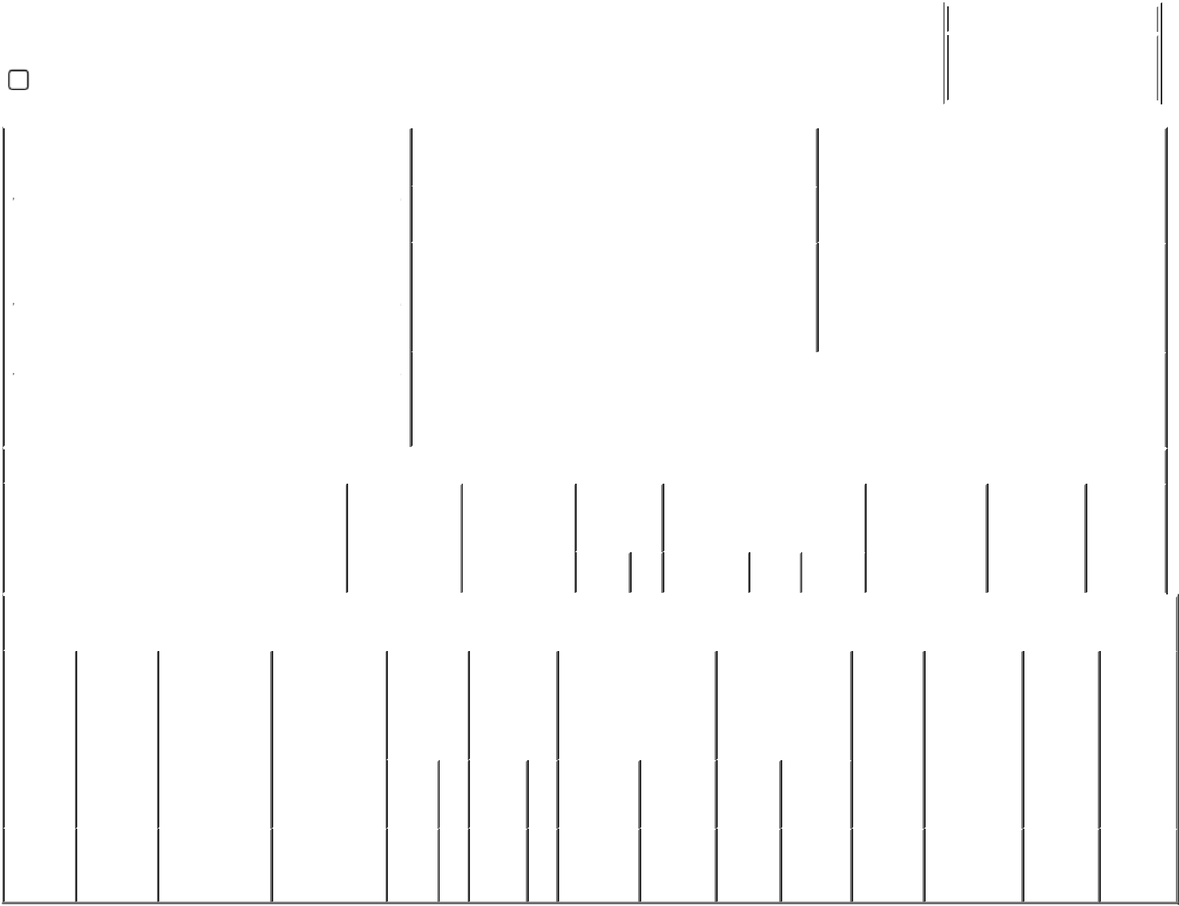

|  |  |  |
| --- | --- | --- |
| Buy) | Stock |  |
|  |  |

**Explanation of Responses:**

1. The shares subject to the option vest in full on the first anniversary of the date of grant, subject to the recipient's Continuous Service (as defined in the Company's 2021 Equity Incentive Plan) through such vesting date; provided, that, if earlier, the shares subject to the option will vest in full upon the occurrence of either of the following events: the Company's next annual stockholder meeting or a Change in Control (as defined in the 2021 Equity Incentive Plan).

**Remarks:**

|  |  |  |  |  |
| --- | --- | --- | --- | --- |
| /s/ Josh Seidenfeld, Attorney- | | 05/30/2023 | |  |
| in-Fact for Dennis Ausiello |  |  |
|  |  |  |
| ** Signature of Reporting Person | |  | Date |  |

Reminder: Report on a separate line for each class of securities beneficially owned directly or indirectly.

* If the form is filed by more than one reporting person, *see* Instruction 4 (b)(v).

* Intentional misstatements or omissions of facts constitute Federal Criminal Violations *See* 18 U.S.C. 1001 and 15 U.S.C. 78ff(a). Note: File three copies of this Form, one of which must be manually signed. If space is insufficient, *see* Instruction 6 for procedure.

**Persons who respond to the collection of information contained in this form are not required to respond unless the form displays a currently valid OMB Number.**