SEC Form 3
FORM 3 | UNITED STATES SECURITIES AND EXCHANGE
 | COMMISSION
 |  |  | OMB APPROVAL
 | Washington, D.C. 20549
 |  |  | OMB Number: | 3235-
 | INITIAL STATEMENT OF BENEFICIAL OWNERSHIP OF |  |  | 0104
 |  |  | Estimated average burden
 | SECURITIES |  |  | 0.5
hours per
response:

Filed pursuant to Section 16(a) of the Securities Exchange Act of 1934
or Section 30(h) of the Investment Company Act of 1940
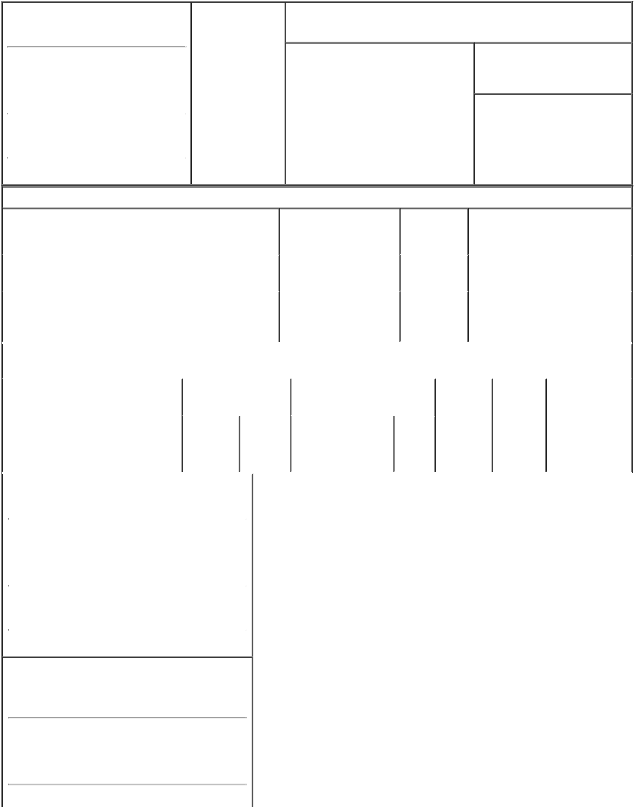

1. Name and Address of Reporting Person |  |  | * | 2. Date of Event
 |  |  |  | Requiring Statement
 | Quiroga Moreno Isidoro
 |  |  |  | (Month/Day/Year)
 |  |  |  | 07/29/2021

3. Issuer Name and Ticker or Trading Symbol

Rani Therapeutics Holdings, Inc. [ RANI ]

(Last) | (First) | (Middle)
AVENIDA PRESIDENTE RIESCO
5711 OFICINA 1603, LAS CONDES
(Street)
SANTIAGO F3 |  | 7550000
(City) | (State) | (Zip)

- Relationship of Reporting Person(s) to Issuer
(Check all applicable)

Director X 10% Owner

Officer (give Other (specify
title below) below)

- If Amendment, Date of Original Filed (Month/Day/Year)

07/29/2021

- Individual or Joint/Group Filing (Check Applicable Line)

Form filed by One Reporting Person

- Form filed by More than One Reporting Person

Table I - Non-Derivative Securities Beneficially Owned

 | 1. Title of Security (Instr. 4) |  |  |  |  |  |  |  |  | 2. Amount of Securities |  | 3. Ownership |  | 4. Nature of Indirect Beneficial
 |  |  |  |  |  |  |  |  |  | Beneficially Owned (Instr. |  | Form: Direct |  | Ownership (Instr. 5)
 |  |  |  |  |  |  |  | 4) |  |  |  | (D) or Indirect
 |  |  |  |  |  |  |  |  |  |  |  | (I) (Instr. 5)
 | Class A Common Stock |  |  |  |  |  |  |  |  |  | 2,956,629⁽¹⁾ | _{I}(1) |  | Shares indirectly held through
 |  |  |  |  |  |  |  |  |  |  |  |  |  | South Lake One LLC⁽²⁾
 |  |  |  |  |  |  |  |  |  |  |  |  |  | Shares indirectly held through
 | Class A Common Stock |  |  |  |  |  |  |  |  |  | 2,316,121⁽¹⁾ | _{I}(1) |  | Aequanimitas Limited
 |  |  |  |  |  |  |  |  |  |  |  |  |  | Partnership⁽³⁾
 |  |  |  |  |  |  | Table II - Derivative Securities Beneficially Owned
 |  |  |  |  |  | (e.g., puts, calls, warrants, options, convertible securities)
 | 1. Title of Derivative Security (Instr. 4) |  |  |  |  |  | 2. Date Exercisable and |  |  |  | 3. Title and Amount of Securities |  | 4. |  | 5. | 6. Nature of
 |  |  |  |  |  |  | Expiration Date |  |  |  | Underlying Derivative Security |  | Conversion |  | Ownership | Indirect Beneficial
 |  |  |  |  |  |  | (Month/Day/Year) |  |  |  | (Instr. 4) |  | or Exercise |  | Form: | Ownership (Instr.
 |  |  |  |  |  |  |  |  |  |  |  |  | Price of |  | Direct (D) | 5)
 |  |  |  |  |  |  |  |  |  |  |  | Amount
 |  |  |  |  |  |  |  |  |  |  |  |  | Derivative |  | or Indirect
 |  |  |  |  |  |  |  |  |  |  |  | or | Security |  | (I) (Instr. 5)
 |  |  |  |  |  |  |  |  |  |  |  | Number
 |  |  |  |  |  |  | Date | Expiration |  |  |  | of
 |  |  |  |  |  |  | Exercisable | Date |  |  | Title | Shares
 | 1. Name and Address of Reporting Person*
 |  |  | Quiroga Moreno Isidoro
 |  |  | (Last) | (First) |  | (Middle)
 |  |  | AVENIDA PRESIDENTE RIESCO
 |  |  | 5711 OFICINA 1603, LAS CONDES
 | (Street)
 |  |  | SANTIAGO | F3 |  | 7550000
 |  |  | (City) | (State) |  | (Zip)

1. Name and Address of Reporting Person*
South Cone Investments Limited

Partnership

(Last) (First) (Middle)

AVENIDA PRESIDENTE RIESCO

5711 OFICINA 1603, LAS CONDES

(Street)

SANTIAGO | F3 | 7550000
(City) | (State) | (Zip)

Explanation of Responses:

- This amendment to Isidoro Quiroga Moreno's Form 3, originally filed with the SEC on July 29, 2021, is being filed to (i) correct the number of shares of Class A Common Stock of Rani Therapeutics Holdings, Inc. (the "Issuer") beneficially owned by Isidoro Quiroga Moreno, as set forth in Table I to the initial Form 3 filing, and (ii) to add an additional Reporting Person, South Cone Investments Limited Partnership ("South Cone"), the entity through which Isidoro Quiroga Moreno indirectly controls South Lake One LLC ("South Lake") and Aequanimitas Limited Partnership ("Aequanimitas"), which may be deemed an indirect beneficial owner of the reported securities and was omitted from the initial Form 3 filing.

- Isidoro Quiroga Moreno indirectly controls South Lake, which has sole voting power and sole dispositive power with respect to all of the shares of the Issuer's Class A Common Stock held by it. South Lake is wholly owned by South Cone, which is controlled by its general partner Inversiones El Aromo Limitada ("El Aromo"), which is controlled by Isidoro Quiroga Moreno (who directly owns approximately 71% of the issued and outstanding capital stock of El Aromo).

- Isidoro Quiroga Moreno indirectly controls Aequanimitas, which has sole voting power and sole dispositive power with respect to all of the shares of the Issuer's Class A

Common Stock held by it. Aequanimitas is controlled by its general partner, South Lake Three LLC, which is wholly owned by South Cone, which is controlled by its general partner El Aromo, which is controlled by Isidoro Quiroga Moreno (who directly owns approximately 71% of the issued and outstanding capital stock of El Aromo).

Remarks:

This Form 3/A amends and restates in its entirety the Form 3 filed on July 29, 2021 for the sole purpose of correcting the number of shares of Class A Common Stock of the Issuer beneficially owned by the Reporting Persons and including South Cone as an additional Reporting Person.

/s/ Isidoro Quiroga
Moreno

/s/ Isidoro Quiroga Cortes;

and /s/ Luis Felipe Correa

Gonzalez, Managers of
Inversiones El Aromo
Limitada, as General
Partner and on behalf of

South Cone Investments

Limited Partnership

08/03/2021

08/03/2021

** Signature of Reporting | Date
Person
Reminder: Report on a separate line for each class of securities beneficially owned directly or indirectly.
* If the form is filed by more than one reporting person, see Instruction 5 (b)(v).

- Intentional misstatements or omissions of facts constitute Federal Criminal Violations See 18 U.S.C. 1001 and 15 U.S.C. 78ff(a). Note: File three copies of this Form, one of which must be manually signed. If space is insufficient, see Instruction 6 for procedure.
Persons who respond to the collection of information contained in this form are not required to respond unless the form displays a currently valid OMB Number.

